A Quick Survival Guide To Staying Home with Children During COVID-19

With all of the uncertainty due to COVID 19, we have put together some reliable resources to give you some ideas and support for getting through this period.

- Know the symptoms of stress and anxiety in children. The CDC has excellent information worth reviewing here.
- There is a general feeling of heightened anxiety right now, and children are likely to pick up on it and become worried. A few things that may help are:

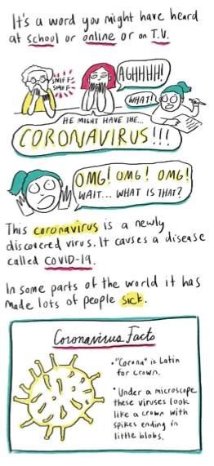
- Validate their anxiety and worry. Ask children what they are worried about specifically. It may surprise you: they may be worrying about grandma, you or the family dog getting sick. But they need to be heard BEFORE you do anything else.
- Tell them it’s ok to feel worried, and reassure them that grownups are working hard to keep everyone safe. In fact, by staying home, children are a big help to the grownups!
- Help them get the information they need at their developmental level. This interactive cartoon and radio story explains COVID 19 in an accessible way.
You might use this as an opportunity for children to learn to get information from reliable sources. The CDC has a wealth of resources and up to date information about the virus.
- Don’t have the news and TV on all day. The constant barrage of “updates” only heightens anxiety.
Help children make a list of activities they can do INSTEAD of technology or social media.
- Put limits on technology and social media and make time for the family to enjoy movies or TV shows together. Make them into events with popcorn and snacks.

- Develop a routine for the next few weeks. Keep it relaxed; this is your chance to take a break
from the morning madness. But that doesn’t mean pajamas until 4 p.m. and breakfast at noon.

- Meet with the adults and map out a plan for childcare and what everyone can do to help. Then call a family meeting and bring the children into the discussion, focusing on the following points:
  - Everyone is in this together
  - That everyone will need to still do work
  - There will be a regular schedule.

- Brainstorm all of the things people in the family have to do. Remember this is an opportunity to show respect for your children’s work of school and, for them, of your work at home and outside the home.
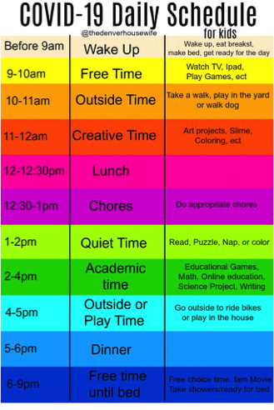

  - Schedule some academics for children. There are lots of resources including teachers pay teachers, homeschool blogs, etc.
  - Chores (see list here of developmentally appropriate chores)
  - Recreation
  - Outside time/Exercise
  - Family time
  - Technology time
  - Meal preparation and baking (this is your chance to learn to bake bread, make cookies, etc.)
  - Quiet time (everyone in their own space, quietly relaxing)
  - Daily clean up times—everyone home is sure to make a lot of mess.

- Use the blank schedule here to make a weekday schedule. When possible, have children work to fill out their schedules (with guidance) to help them develop their planning and time management skills.
- Build in lots of fun things to look forward to such as hikes, crafts, and helping neighbors in need by grocery shopping for them, helping with their yardwork, or making them special treats or meals for delivery.

- Resources for keeping children gainfully occupied include:
- PBSKids is putting together extra programming.
- Scholastic is making materials available for free.
- Learn to code with this free program developed by MIT for children.
- Khan Academy has academic programming at all ages.
- Teachers pay Teachers has a wealth of resource including lesson plans and activities. The cost is very low, and there are terrific campion materials to things you can find on Khan Academy.
- Open Culture is worth exploring—all of its resources are free.
- Two online learning communities are Outschool and BrainPop but there are many others out there.
- Participate in a virtual science fair. Education week is sponsoring one.
- Out of the box ideas:
  - Been meaning to adopt a pet? Now’s the time! The whole family is home to bond with your new buddy. Or teach your dog new tricks—you tube has great tutorials.
  - Been meaning to clean out the garage, toy bin, or closet? Make it a family affair, with children who help getting a share of the profits from the garage sale you’ll have when the quarantine is over. Make it a game: what they organize and tag, they get as profit.
- Use your neighborhood listserv:
  - Many college kids have been sent home and may be willing to help with providing babysitting or academic supervision.
  - Organize a neighborhood art show with art to be displayed in front windows or on apartment doors.

- Fun activities:
  - This is a fun blog with some great ideas, including setting up a virtual playdate.
  - Good Housekeeping has some fun activities with things you might already have.
  - Artful Parents has cool art projects.

- Other resources:
- The Child-Mind Institute has terrific guidance on talking your children about COVID 19.
- Families with especially anxious children will appreciate this article from ADDtidue.
- Adults need to take care of their mental health also. Please look out for symptoms of extreme stress and see the advice from the American Society for Suicide Prevention.

- Try to laugh! Here are a few moments for parents and kids alike to laugh at the current situation:
  - Kid photobombs parent doing CNN interview (an oldie but a goodie).
  - Sing your favorite 20 second chorus while washing your hands. Wash your Lyrics will automatically generate a poster to put on the bathroom mirror. Make it a family project to learn a new chorus each day.

